CLUB Details:
The Department of Computer Science has two clubs.
- Kinesis Technical Society (KTS)
- CP BYTE

Name of Club: Kinesis Technical Society (KTS)
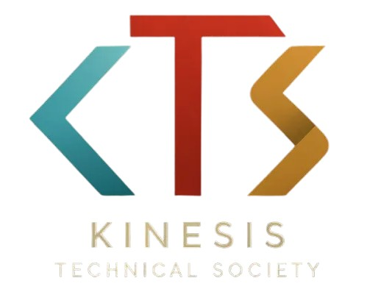
Logo:

Description: Kinesis Technical Society (KTS) is the official technical society of KIET Group of Institutions, built on the pillars of innovation, collaboration, and continuous learning. KTS provides a dynamic platform for students to explore and excel in various domains of technology.
We focus on key areas such as:
• Web Development
• Android Development
• Machine Learning & AI
• UI/UX Design
• Competitive Programming
Our society organizes a wide range of activities including technical workshops, hackathons, coding competitions, and project showcases that encourage hands-on learning and creative problem-solving.
KTS is more than just a club — it's a community of driven individuals who are passionate about technology, eager to innovate, and always ready to learn.

Name of Club : CP BYTE
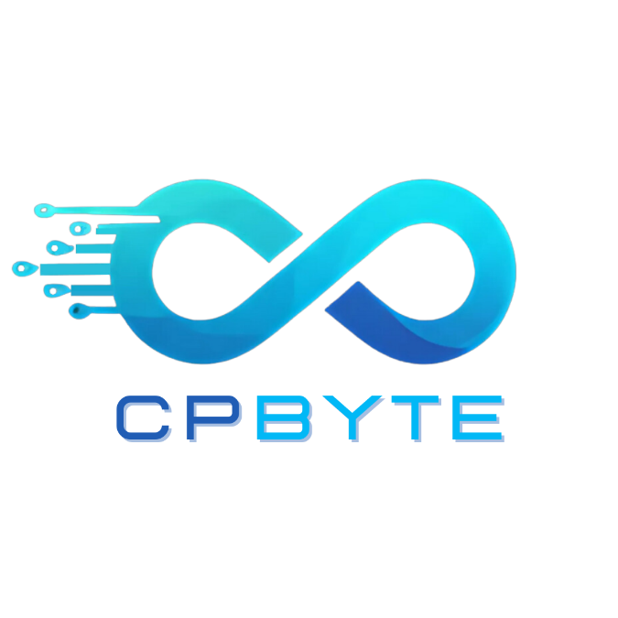
Logo:

Description: Founded in 2022 under the Department of Computer Science, CPBYTE stands as the official technical club of KIET— a community where innovation meets collaboration. What began as a small initiative to nurture coding culture has now grown into a thriving family of 250+ active members, guided by dedicated mentors and experienced seniors who provide invaluable support at every step.
At CPBYTE, we believe in learning by doing. The club regularly conducts bootcamps, workshops, hackathons, and speaker sessions, empowering students to build, explore, and excel in the ever-evolving tech world. From sessions on Web Development, Android Development, Git & GitHub, and Generative AI to flagship events like Stranger Stacks and Dev 101, CPBYTE continually creates meaningful learning experiences.

With strong guidance from our faculty coordinators and senior mentors, we emphasize teamwork, curiosity, and leadership, making CPBYTE not just a club — but a launchpad for innovators, coders, and problem-solvers.

The club works on the following domains:
- Web Development
- Android Development
- Machine Learning
- Augmented Reality and Virtual Reality
- Gen-AI
- UI/UX

